Scoring Charts for Sarac’s Benefit-Risk Assessment Methodology in the Wave 1 Telithromycin Case Study

The scoring chart for CAP, Efficacy, data pooled from phase III comparative and open label and phase IV. For data point in (green area – in favour of drug, red area – in favour of comparator and yellow area, neither in favour)
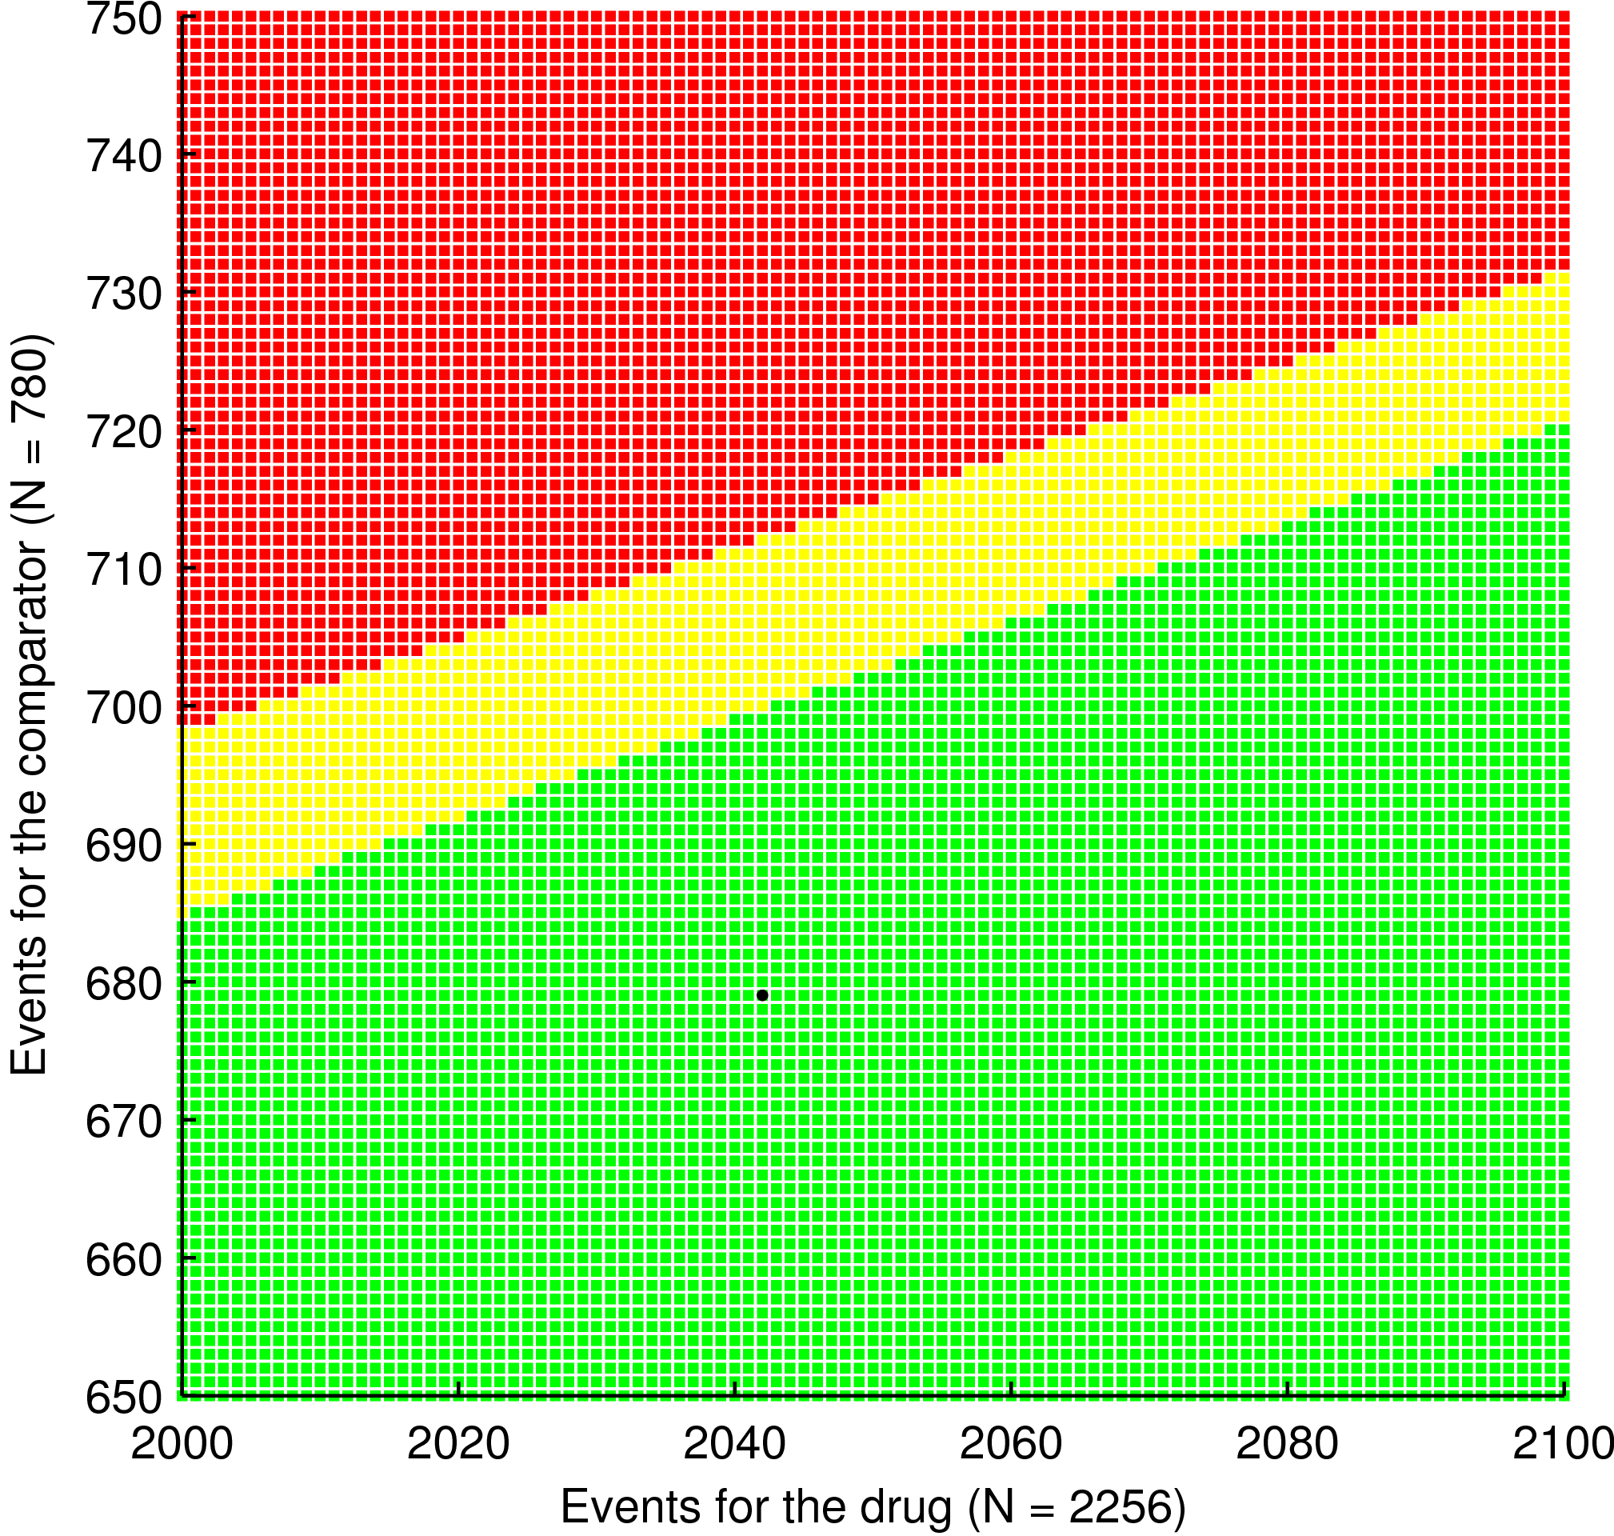
Cured
(2042, 679)

The scoring charts for CAP - AEs. Data pooled from Phase III comparative and open label and phase IV - the right graph shows the bottom left corner of the left graph.
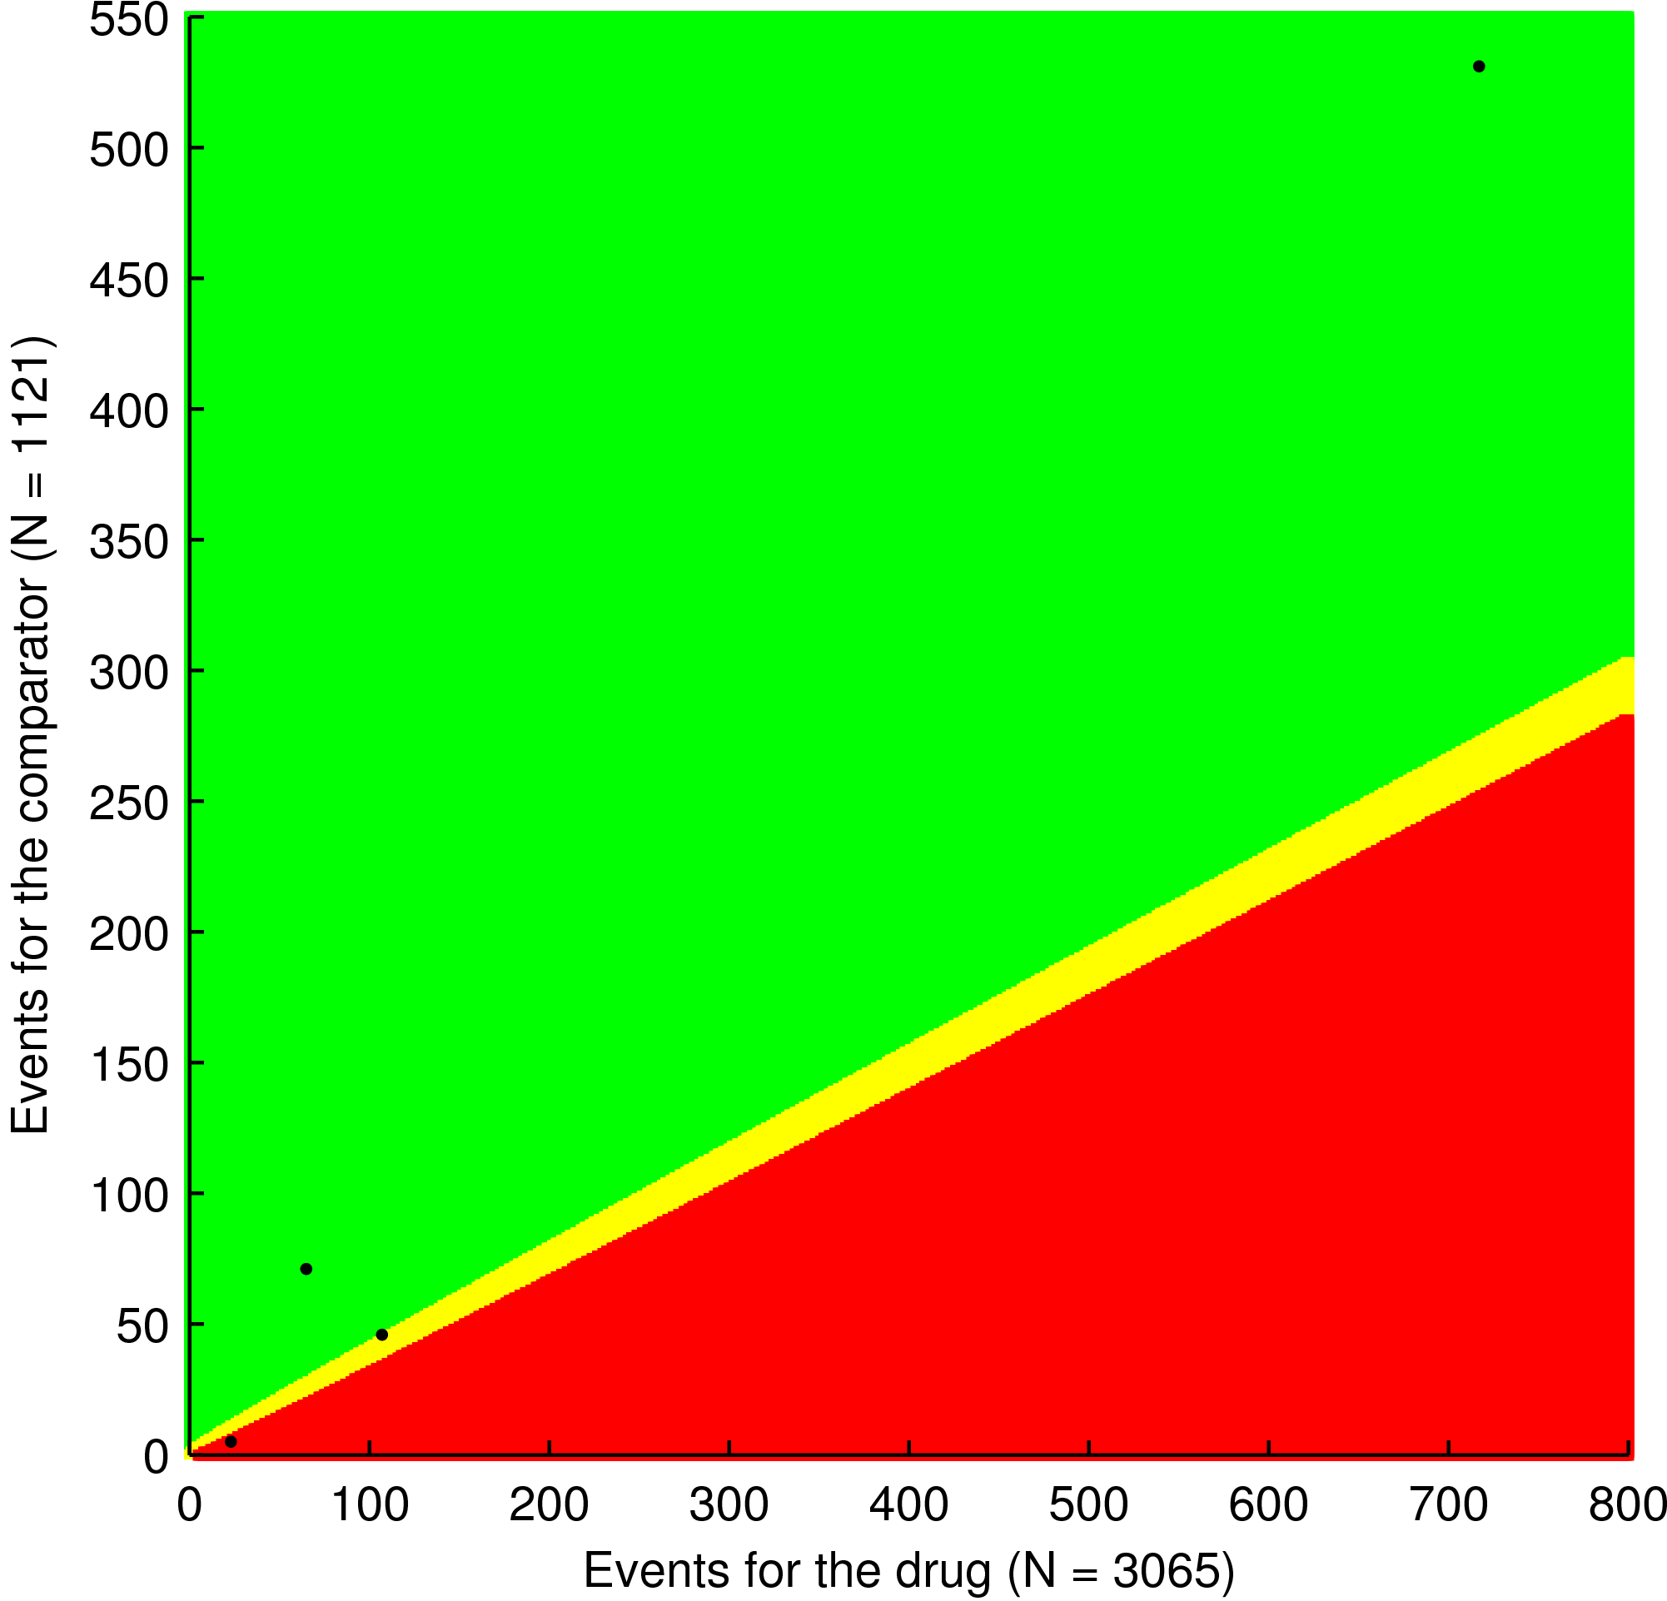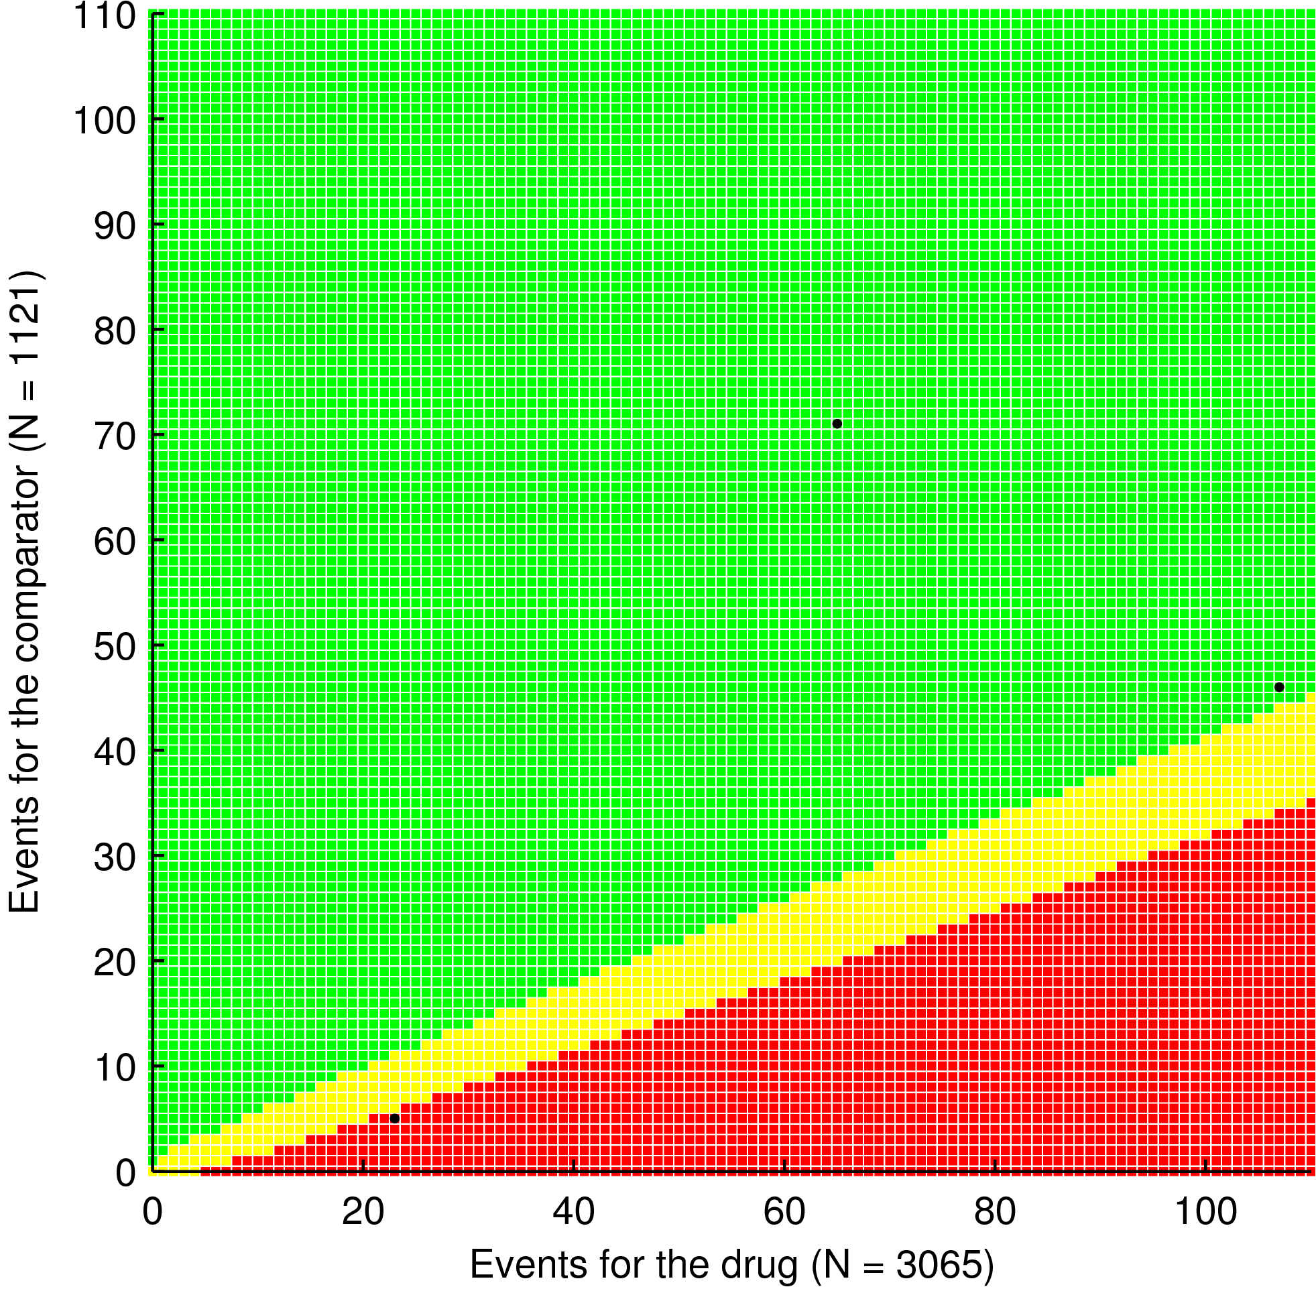
Visual AEs
(23, 5)
Hepatic AEs
(107, 46)
SAEs
(65,71)
TEAEs
(717,531)

The scoring charts for CAP - Cardiac AEs, data pooled from phase III comparative and open label studies to the left and Syncope AEs, data pooled from phase III comparative and phase IV studies to the right.
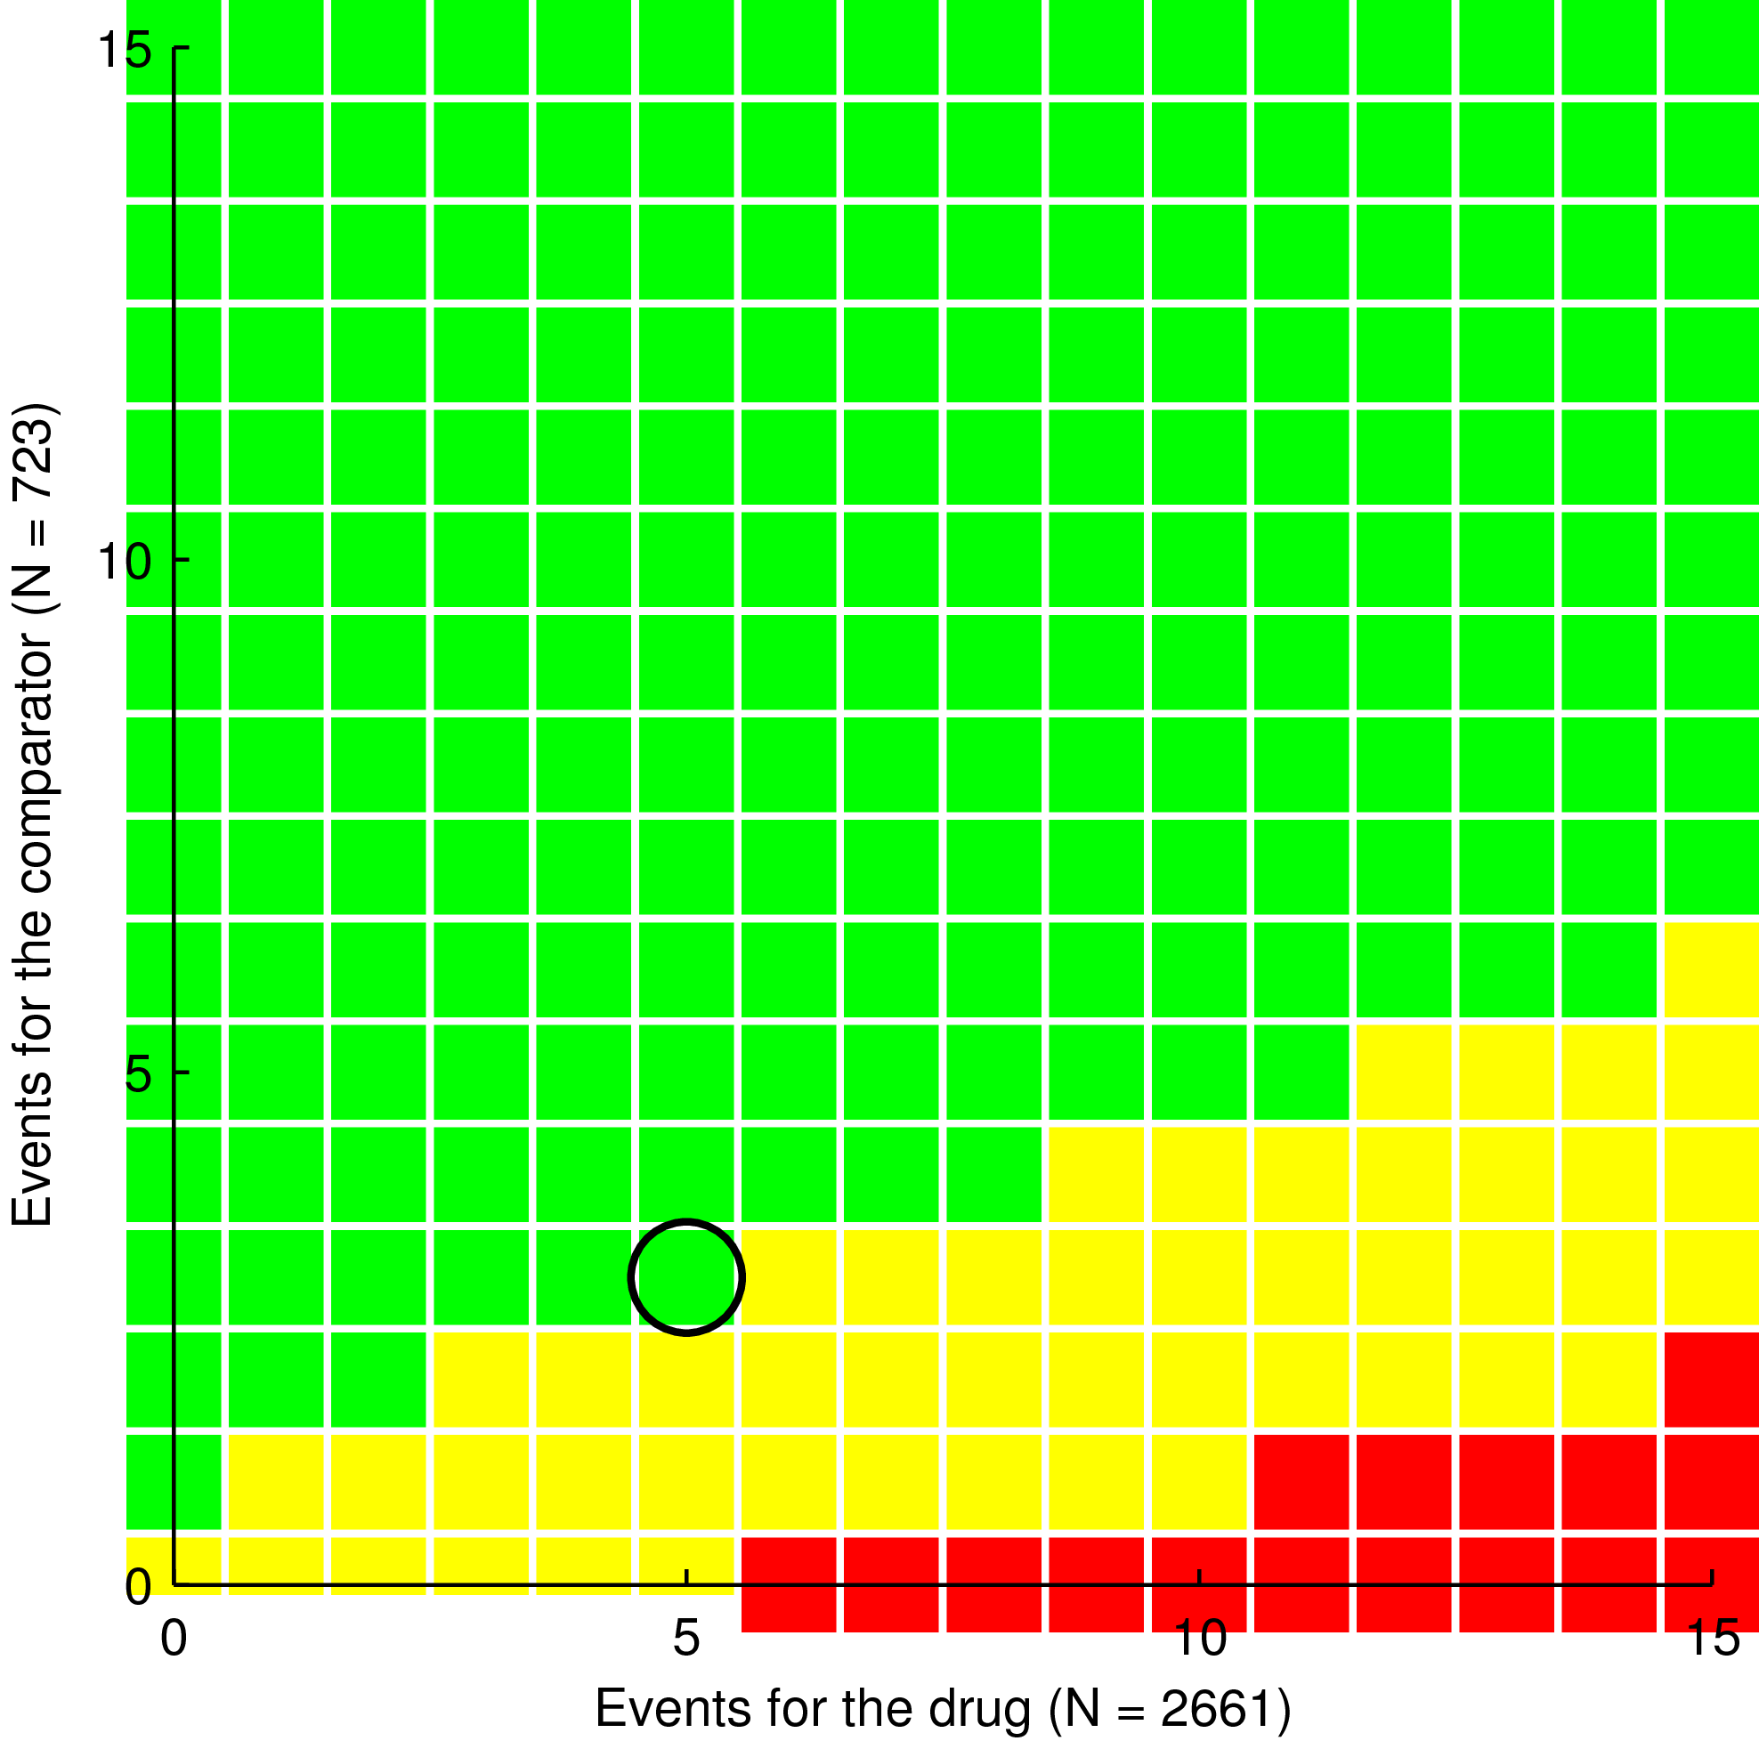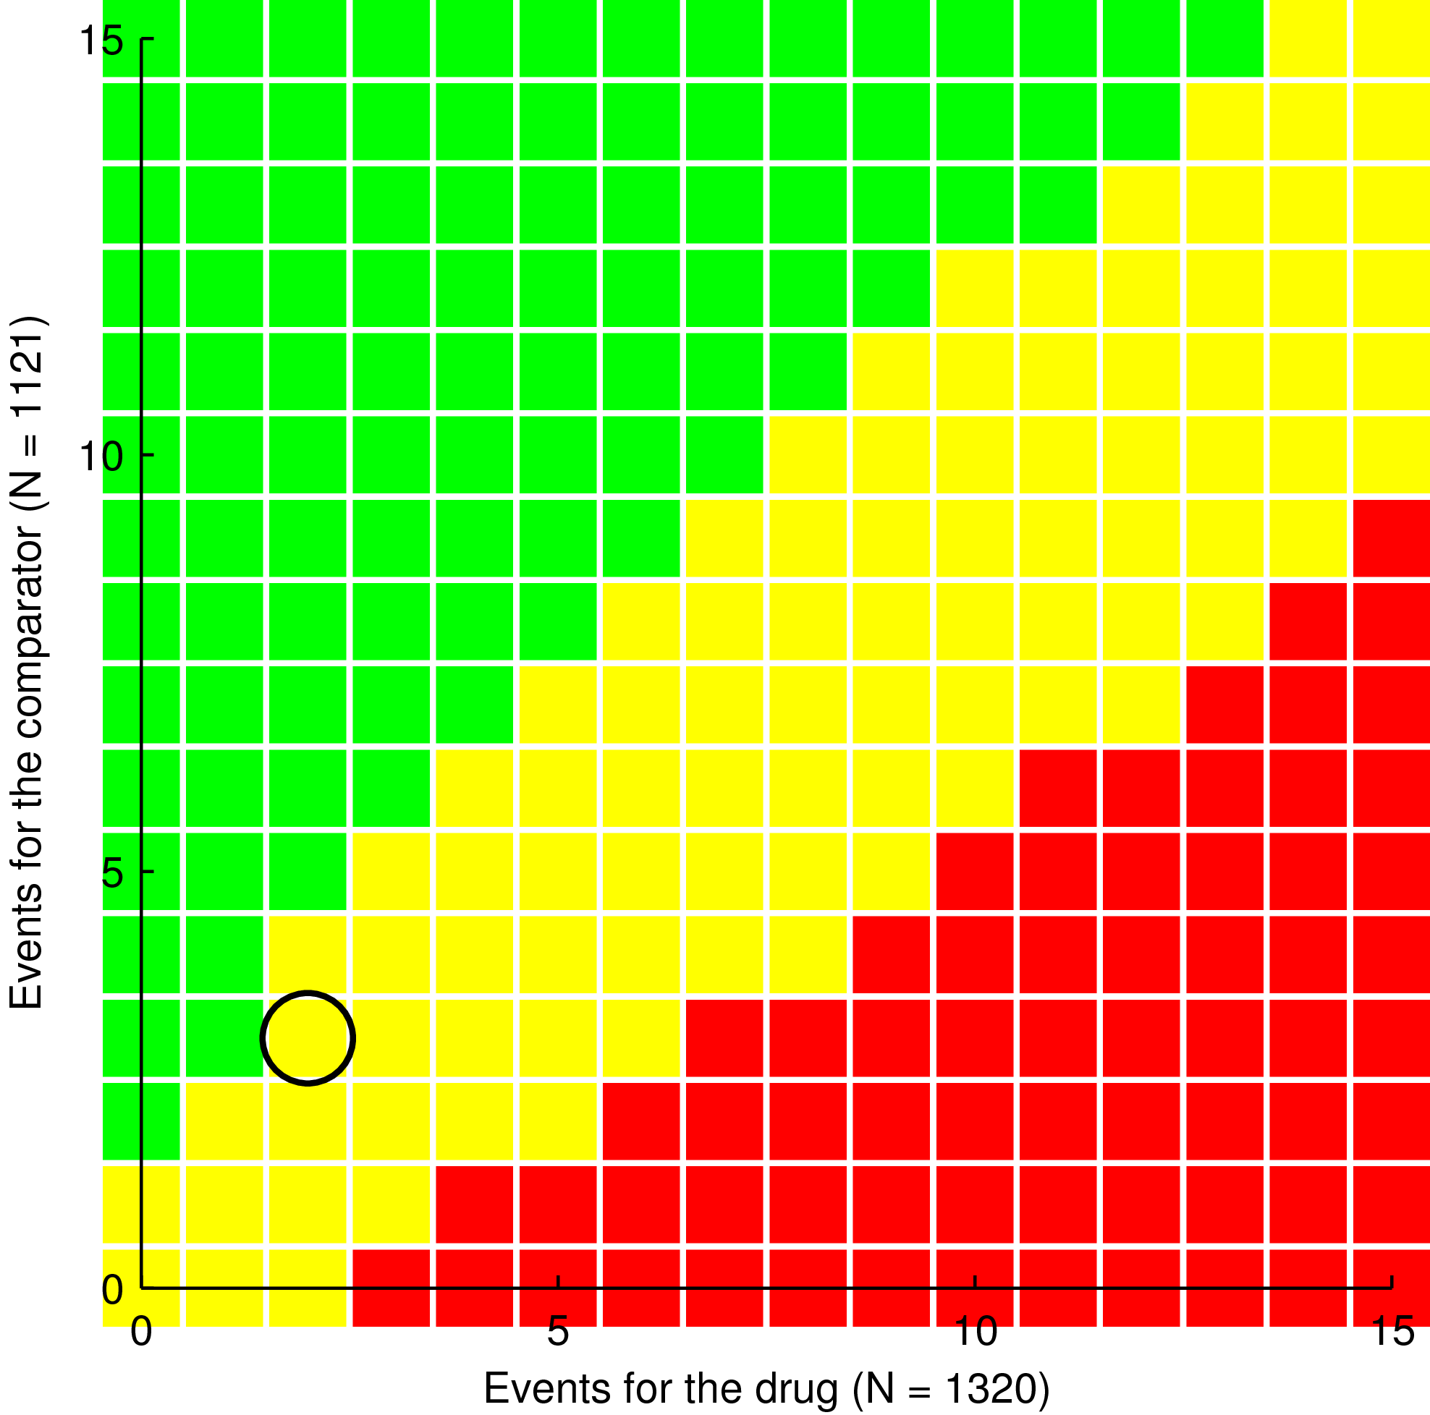

The scoring chart for ABS Efficacy criteria. Data pooled from phase III comparative and open label and phase IV, above.
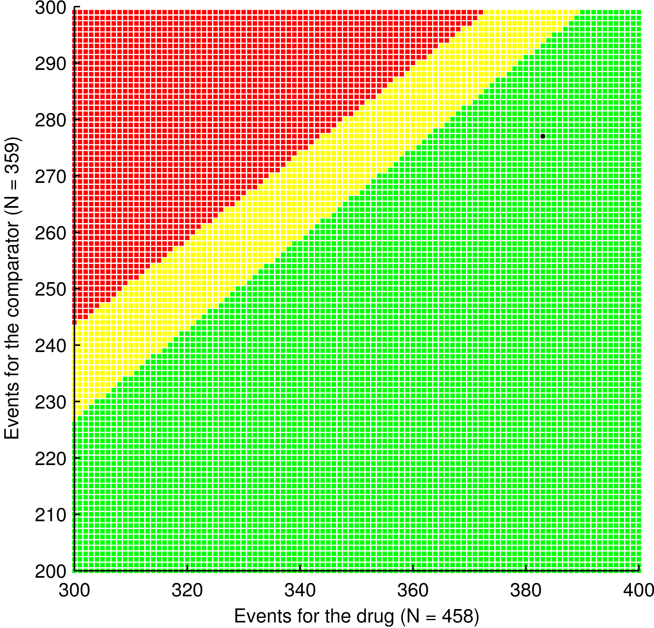
Cured
(383,277)

The scoring charts for ABS risk criteria are shown below. Data pooled from Phase III comparative and open label and phase IV, below - the right graph shows the bottom left corner of the left graph
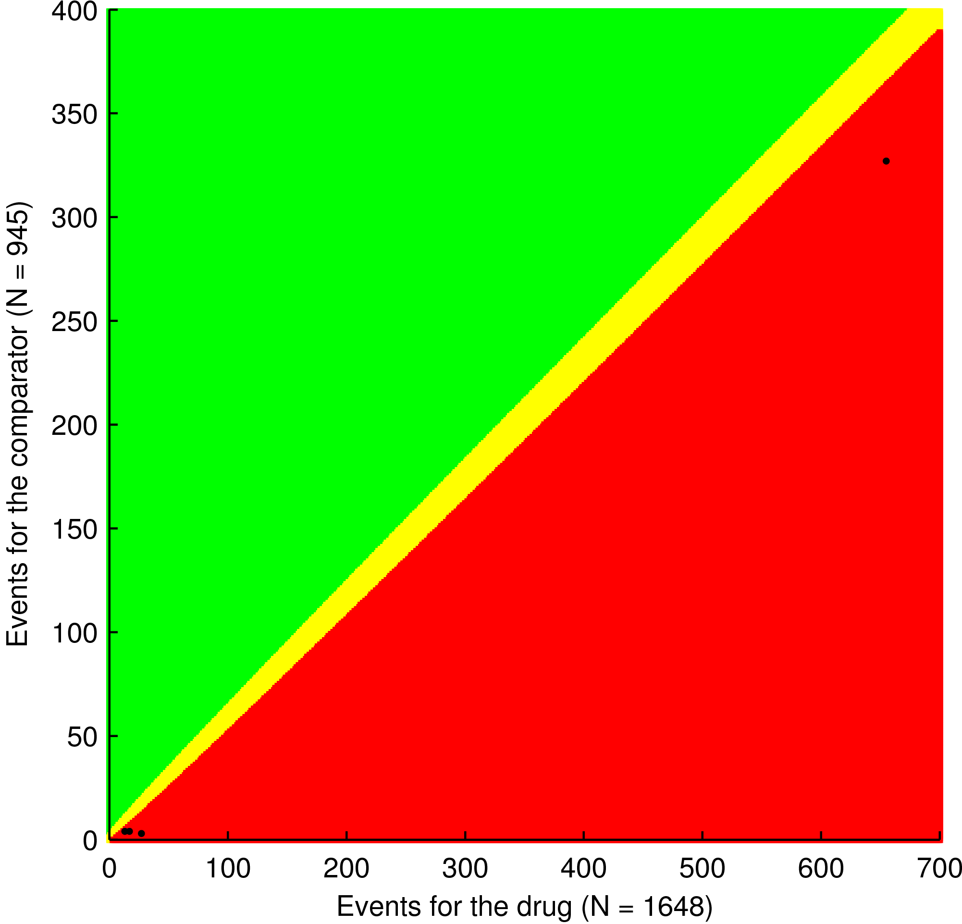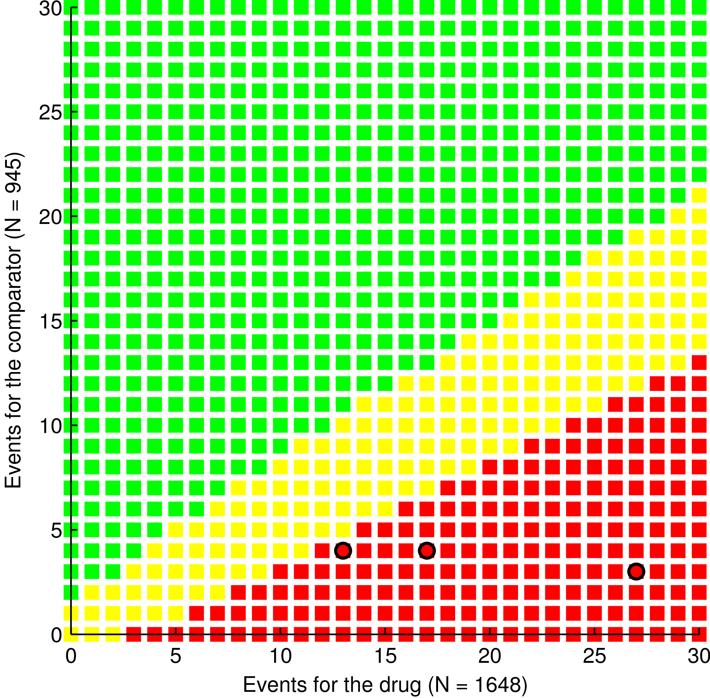
SAEs
(13, 4)
Visual AEs
(17,4)
Hepatic AEs
(27, 3)

TEAEs
(655,327)

Above plots show scoring chart for risk criteria for ABS, Cardiac AEs to the left and Syncope to the right. Data pooled from phase III comparative and open label studies for Cardiac AEs and pooled from phase III comparative and phase IV studies for syncope.
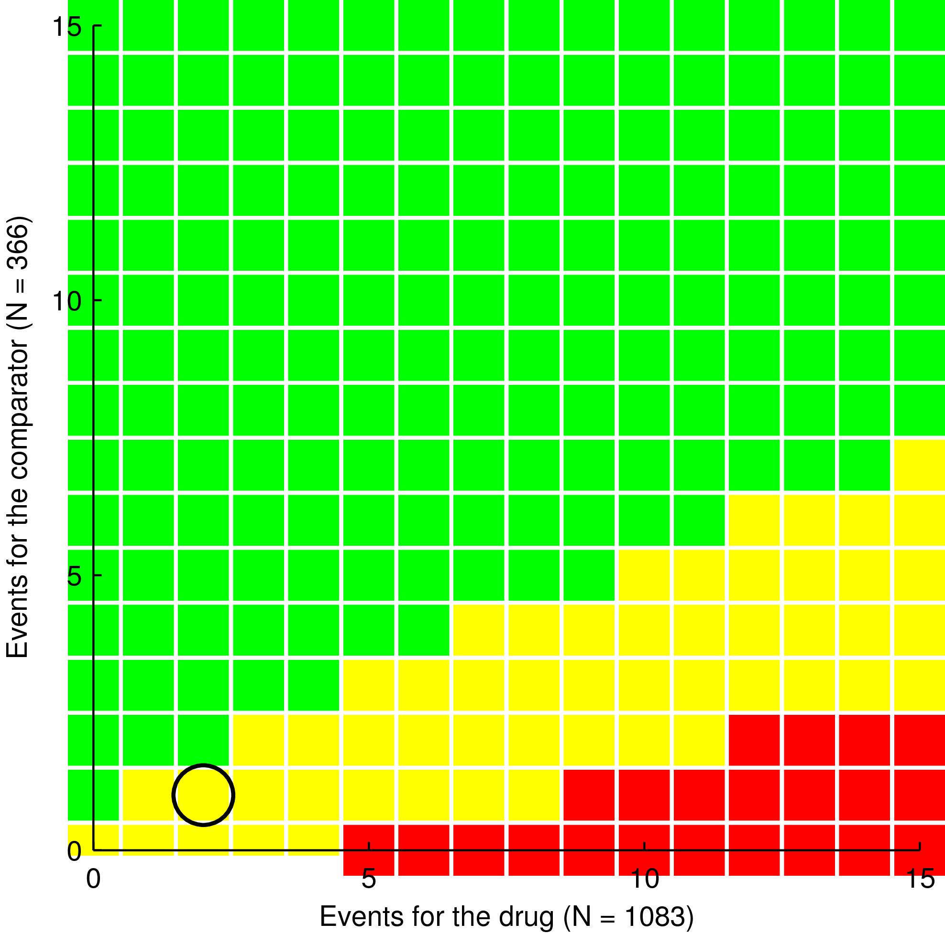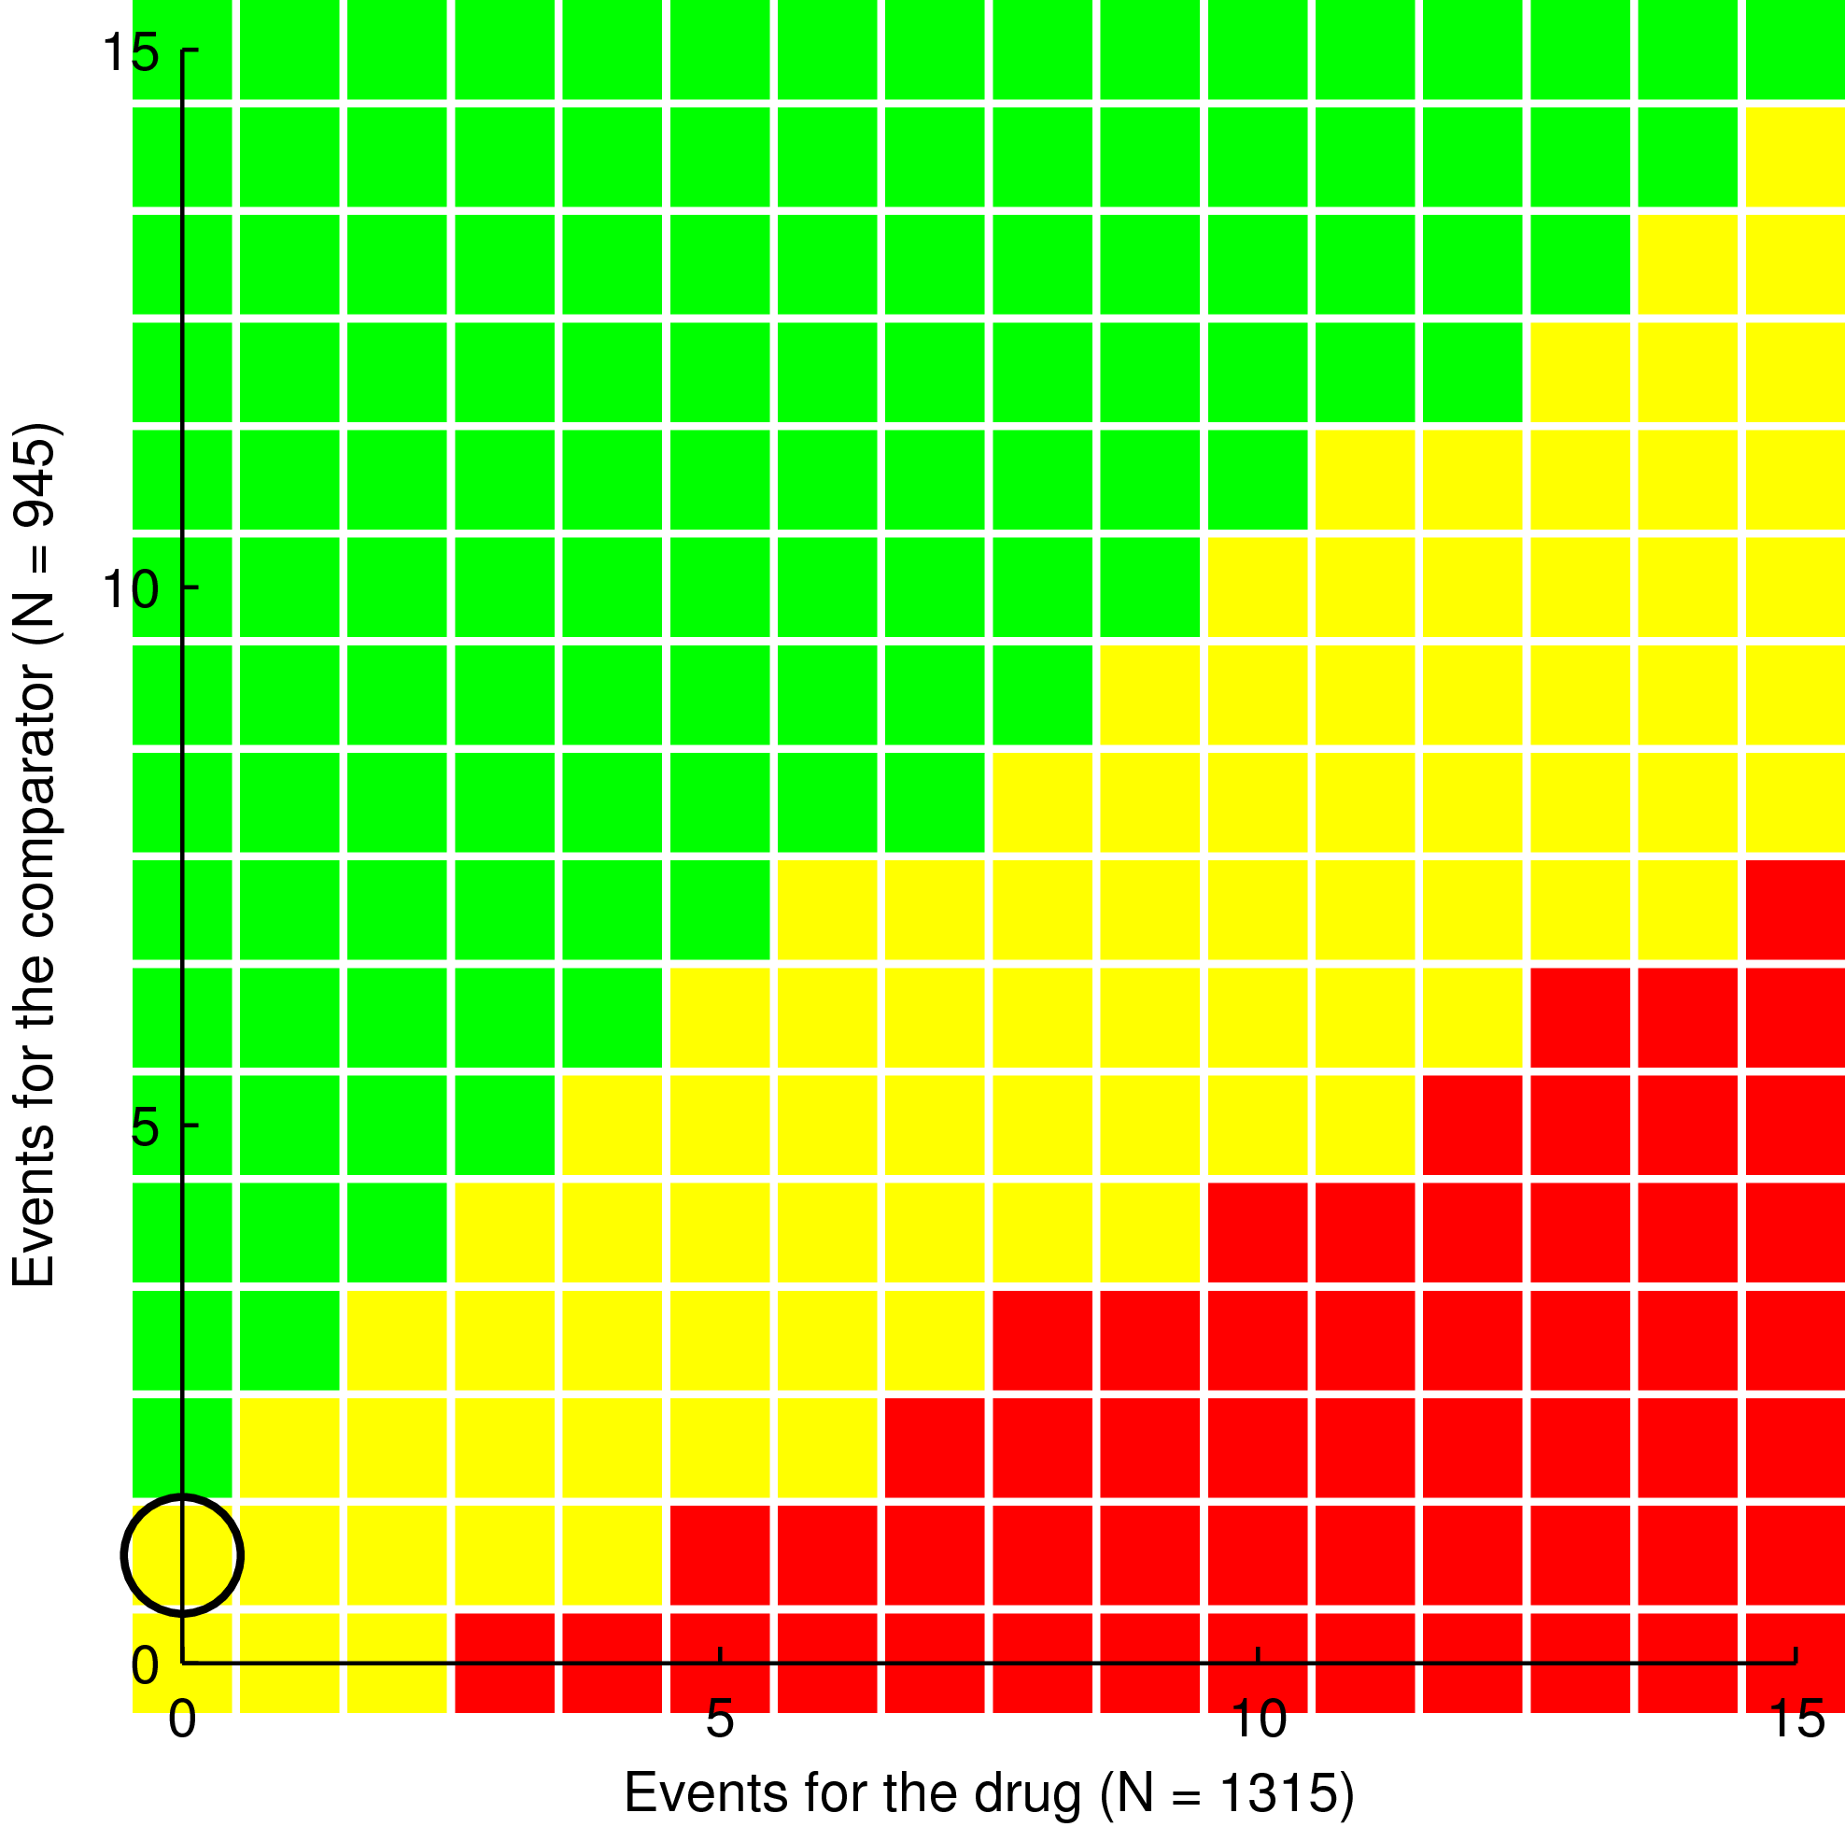

The scoring charts for AECB benefit criteria cure are shown below. Data pooled from phase III comparative and phase IV studies.
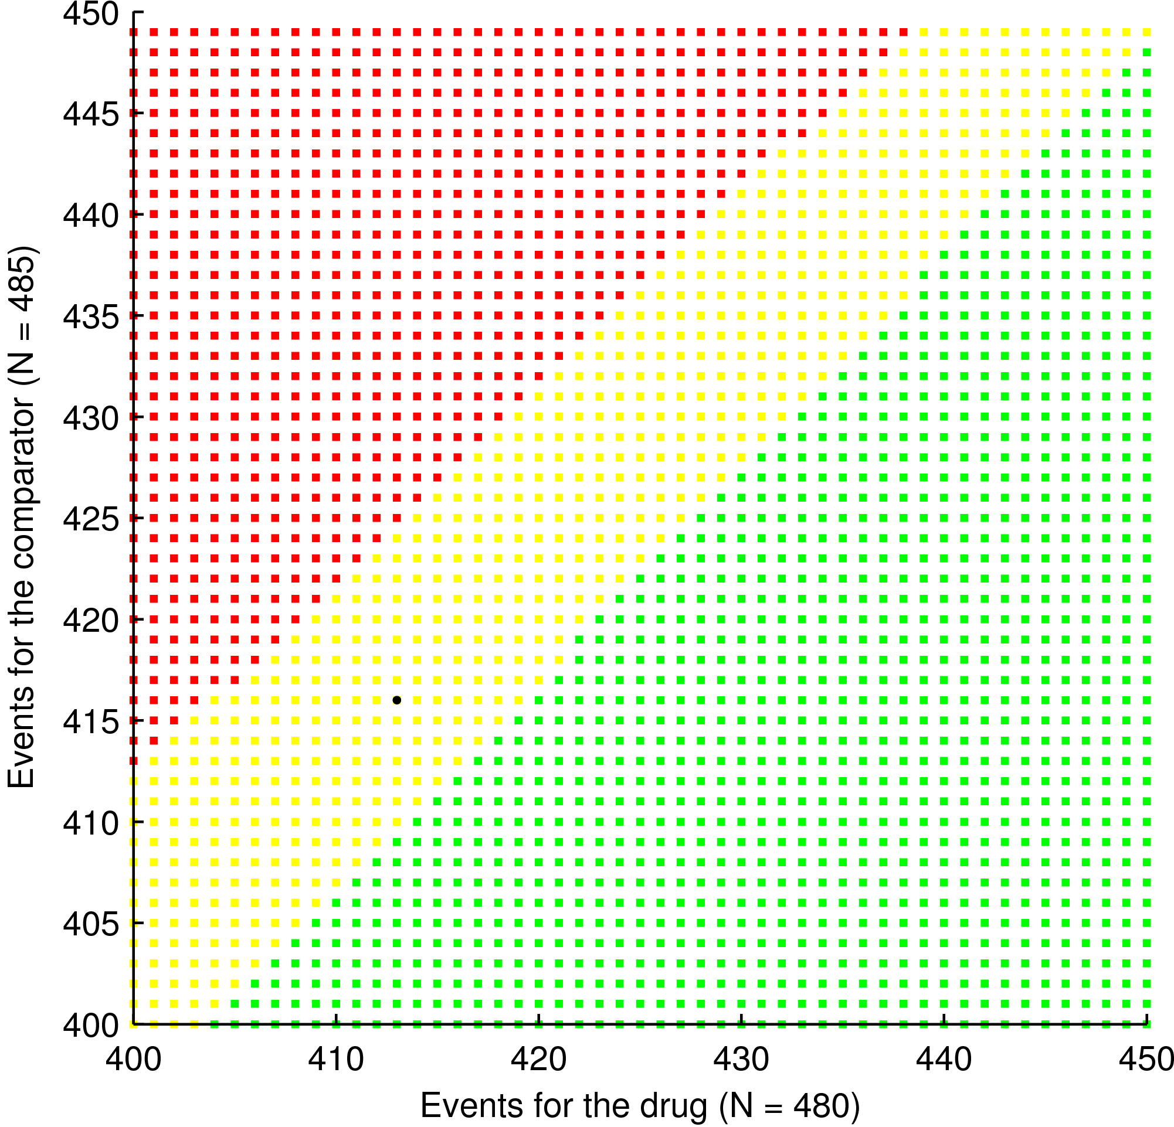
Cured
(413,416)

The scoring chart AECB, benefit criteria PERSp at TOC for telithromycin vs. Cefuroxime, data from phase IV study (left), and AECB, Efficacy PERSp at TOC for telithromycin vs. Aztihromycin, data from phase IV study (right)
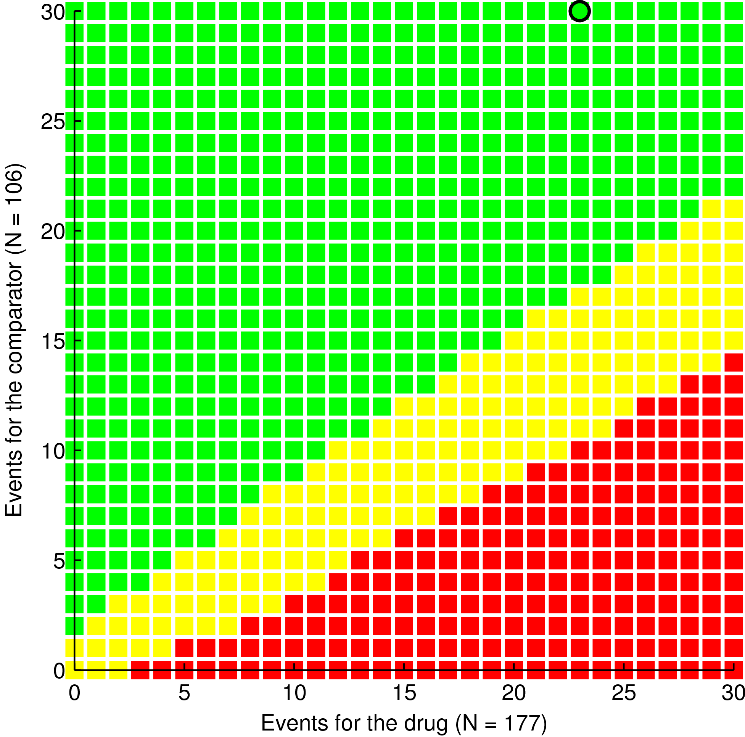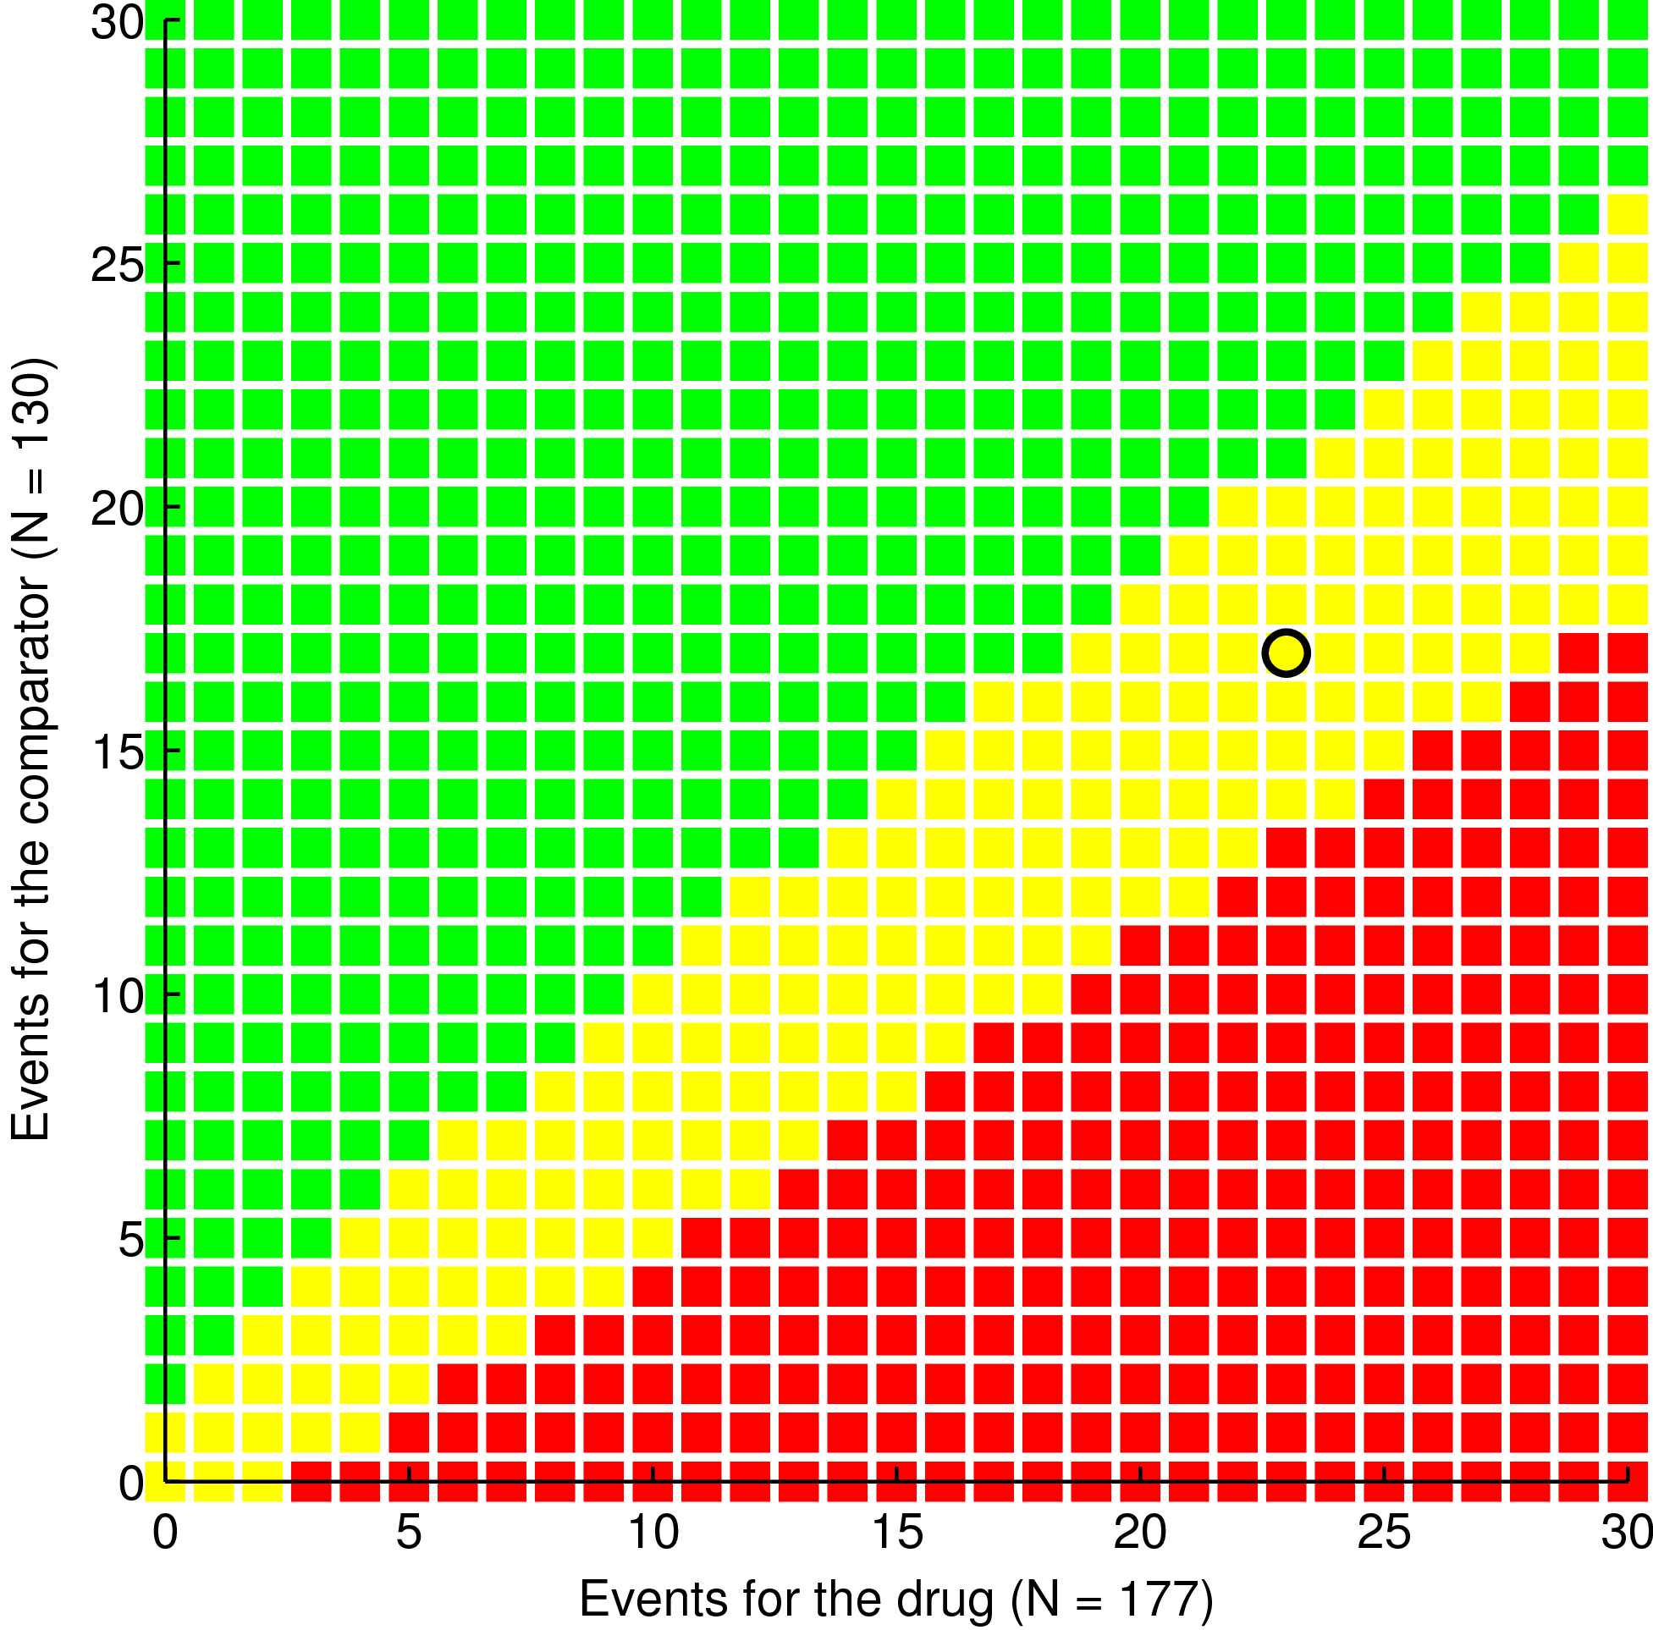

The scoring chart for AECB AEs (left), data pooled from Phase III comparative and phase IV studies. The right graph shows the enlarged bottom left corner of the left graph.
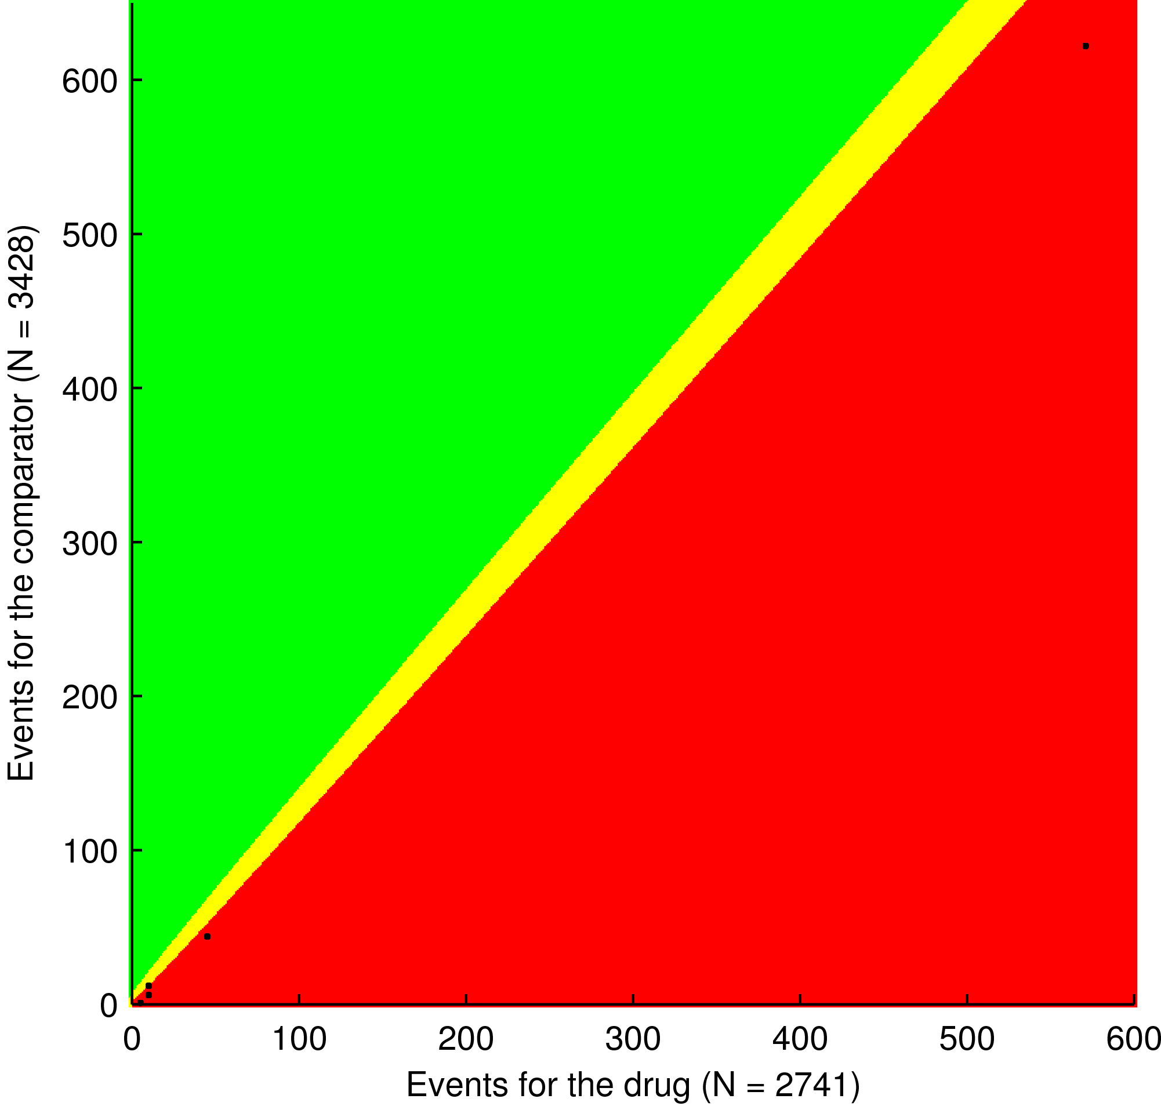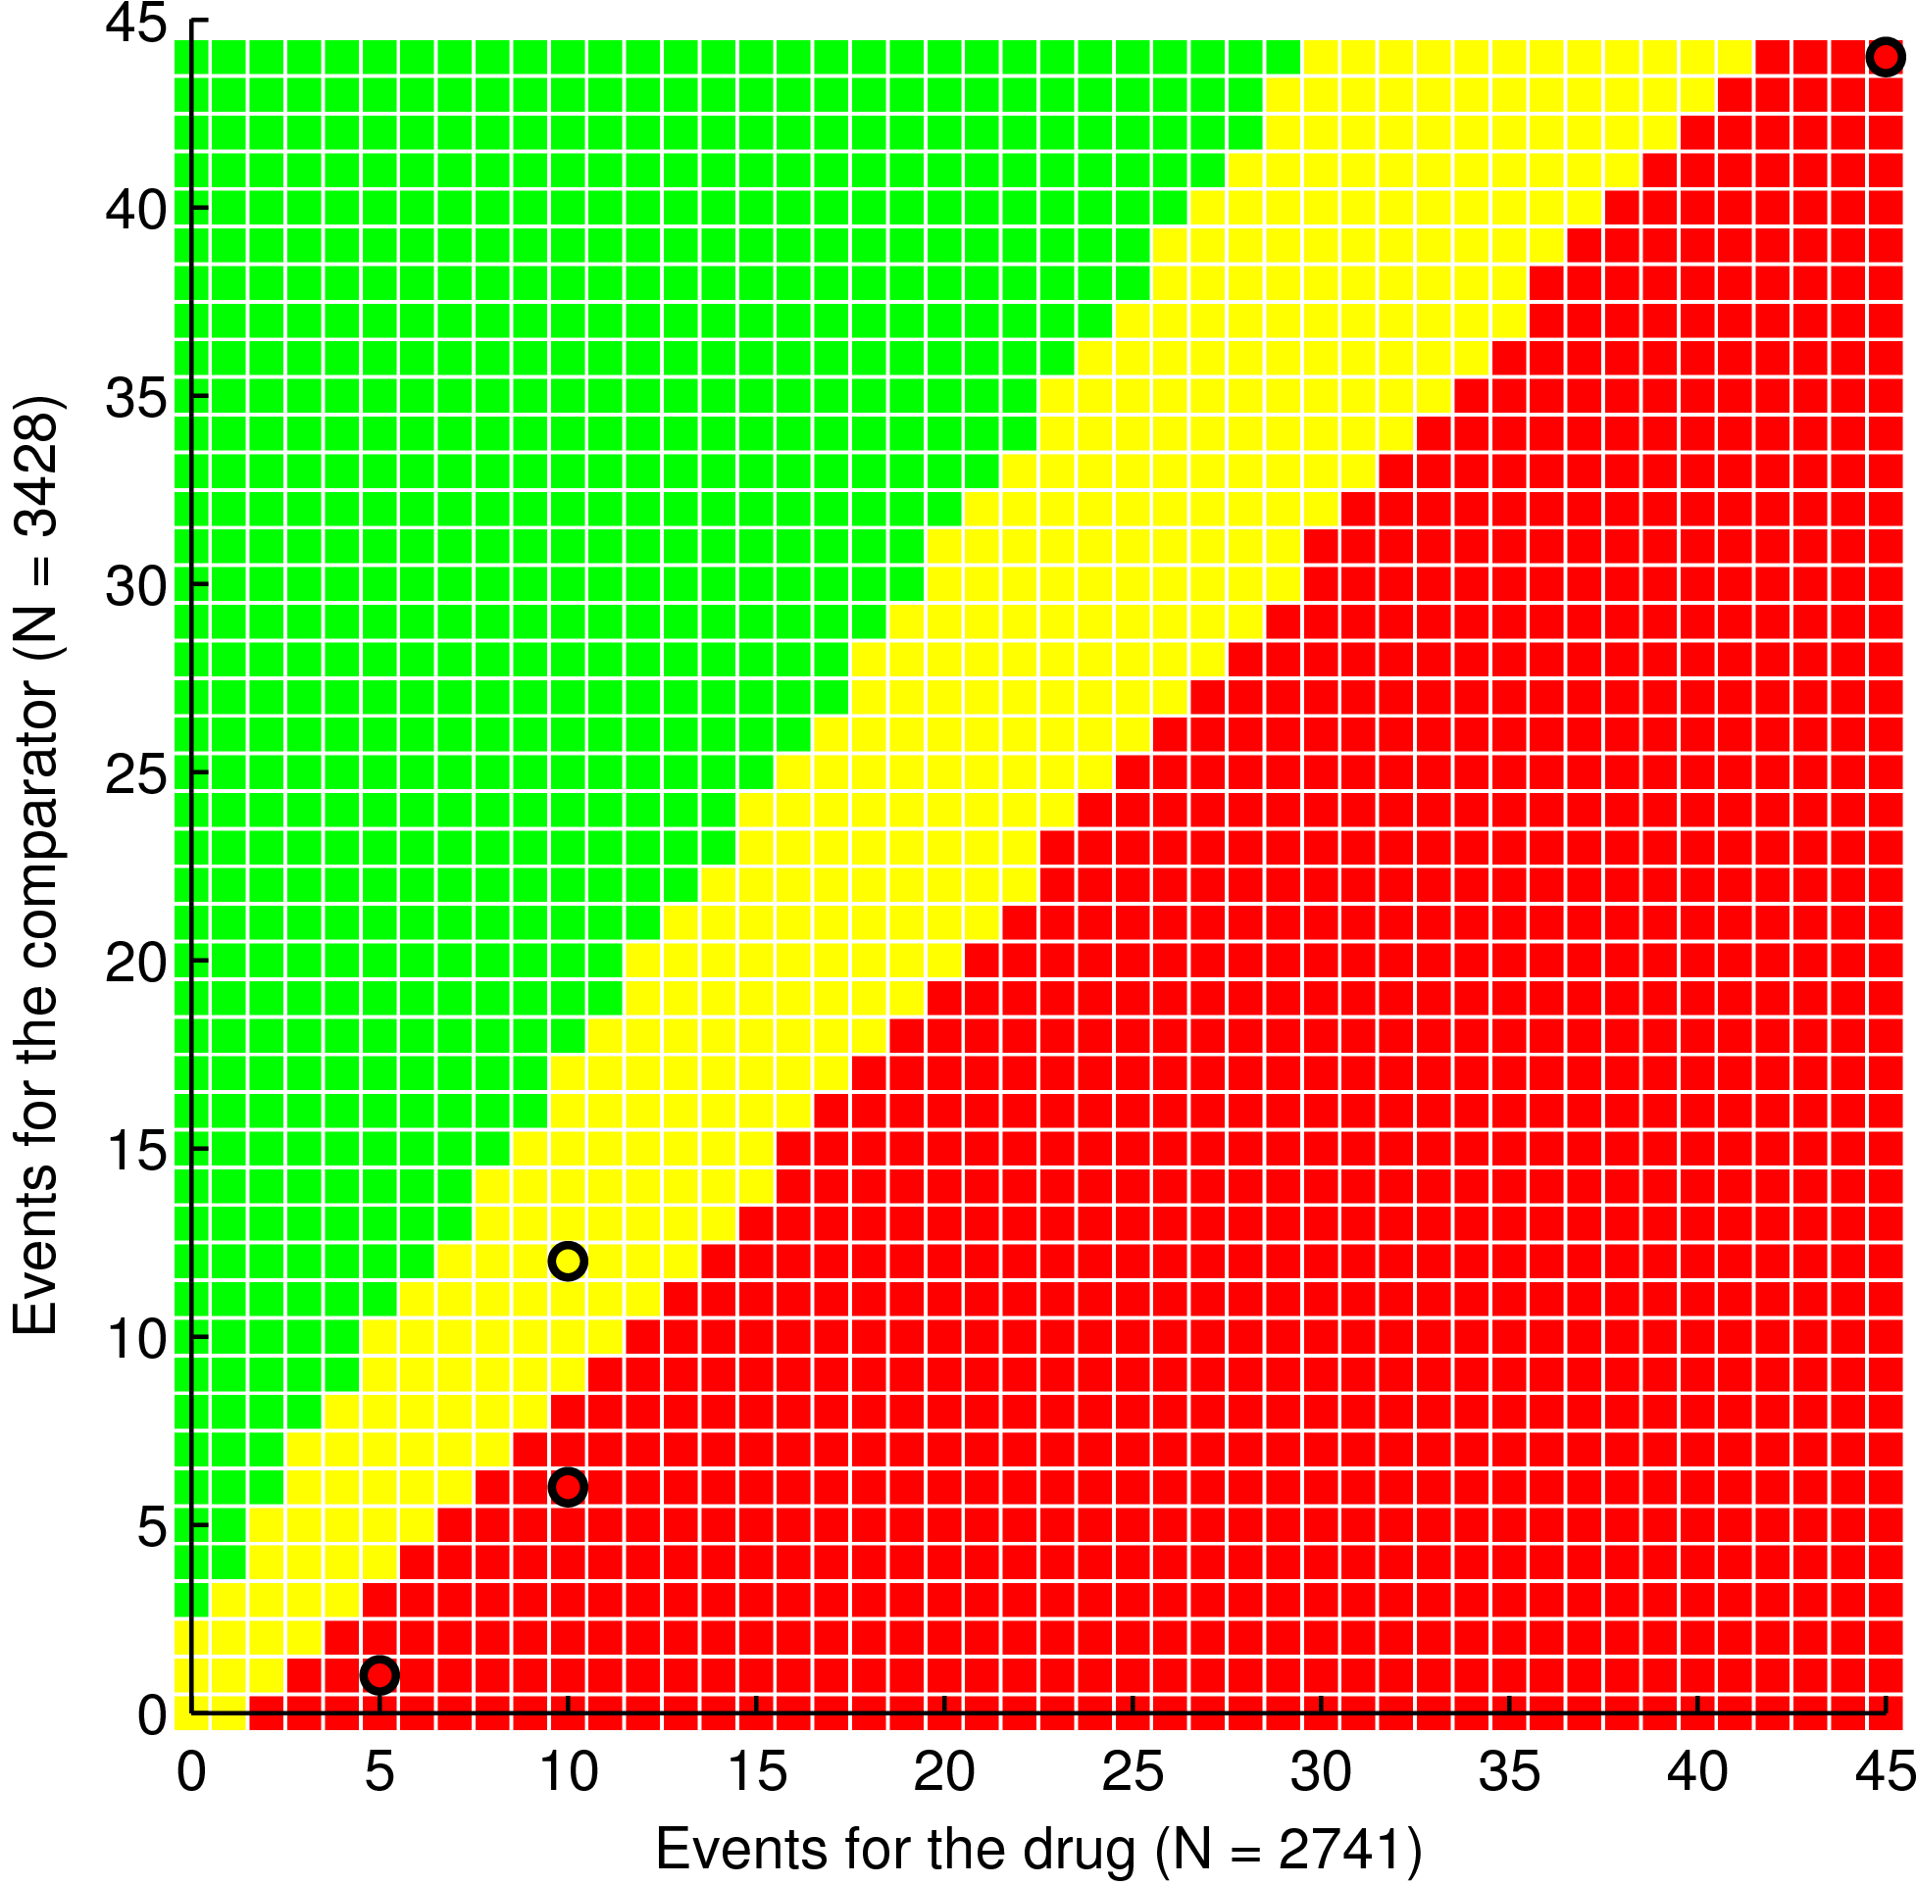
TEAEs (571, 622)
SAEs (45, 44)
Hepatic AEs (10, 12)
Visual AEs (5, 1)
SAEs (45, 44)

