A scatter diagram of incremental risk (AESI) versus incremental benefit (Cure) of telithromycin relative to placebo in a simulation
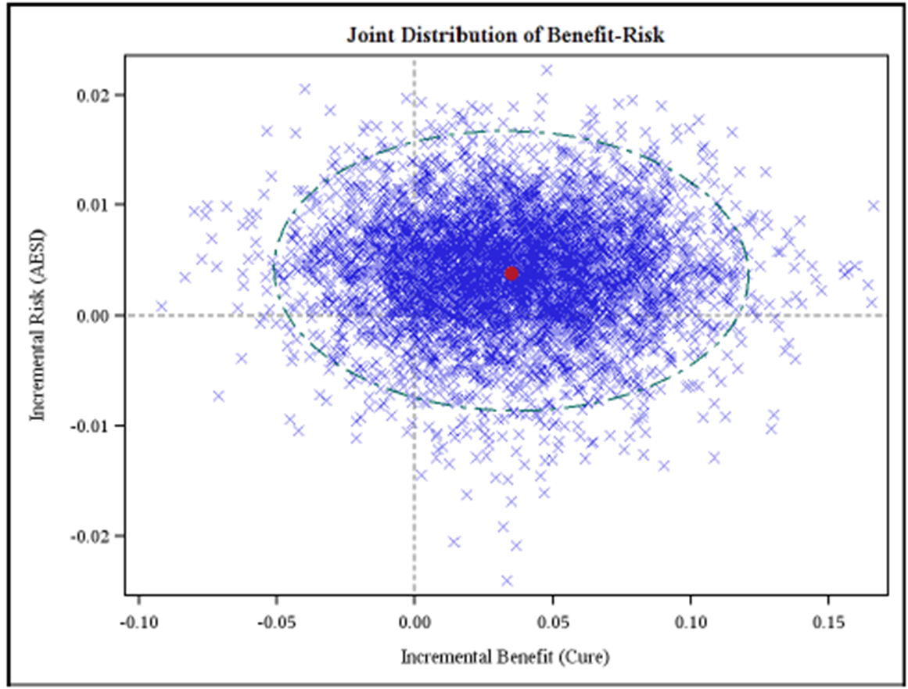
Monte Carlo simulation in IMI-PROTECT telithromycin case study for ABS indication plotted on the risk–benefit plane: the incremental probability of AESI (Hepatic, Syncope, Visual Cardiac) versus. the incremental probability of Cure, with 95% confidence interval. The red dot mark the point estimate of BRR of telithromycin versus placebo.

