Theoretical distribution of results of a clinical trial in which two drugs have been studied; Boada J, Boada C, Garcia MM, Rodriguez C, Garcia M, Fernandez E. Net efficacy adjusted for risk: Further developments. Expert Opinion on Drug Safety 2009;8(6):649-54.
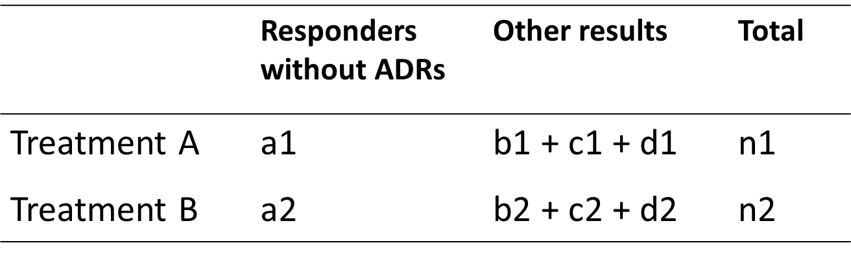
In the second column, the expected frequencies for optimal results obtained with each drug are noted; in the third column, the sum of the remaining expected frequencies for each drug are noted, that is, patients who do not respond and moreover suffer ADRs plus those patients who respond and suffer ADRs plus those patients who do not respond and do not suffer ADRs. Now, let b1+c1+d1=S1 and b2+c2++d2=S2. Then, (a1*S2)/(a2*S1) expresses NEAR OR and (a1/n1)/(a2/n2) expresses NEAR RR. Finally, the CI for these new parameters may be calculated in the following manner:
$$\text{NEAR OR}±\text{CI}95\%=\text{NEAR OR}×e^{±1.96\sqrt{\frac{1}{a1}}+\left(\frac{1}{a2}\right)+\left(\frac{1}{S1}\right)+\left(\frac{1}{S2}\right)} \\ \text{NEAR RR}±\text{CI}95\%=\text{NEAR RR}×e^{±1.96\sqrt{\frac{1}{a1}}-\left(\frac{1}{n1}\right)+\left(\frac{1}{a2}\right)-\left(\frac{1}{n2}\right)}$$

Forest plot for NEAR in an application to a clinical trial comparing cabergoline versus bromocriptine for the treatment of hyperprolactinaemia; reproduced from Boada J, Boada C, Garcia MM, Rodriguez C, Garcia M, Fernandez E. Net efficacy adjusted for risk: Further developments. Expert Opinion on Drug Safety 2009;8(6):649-54.
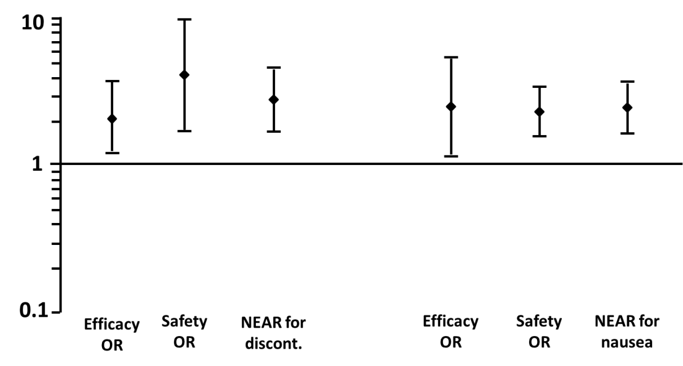
On the left, intention-to-treat analysis is considered: traditional efficacy and safety OR together with NEAR OR, taking discontinuation as the ADR, are presented. On the right, per-protocol analysis is considered: traditional efficacy and safety OR together with NEAR OR, taking nausea as the ADR, are presented. Vertical lines represent 95%CIs.When the lower limit is > 1, the proband drug is preferable.

