Line graphs for NCB proposed in Sutton AJ, Cooper NJ, Abrams KR, Lambert PC, Jones DR. A Bayesian approach to evaluating net clinical benefit allowed for parameter uncertainty. J Clin Epidemiol 2005 Jan;58(1):26-40.

Figure 1 Graphical representation of a net clinical benefit model (reproduced from Sutton et al.)
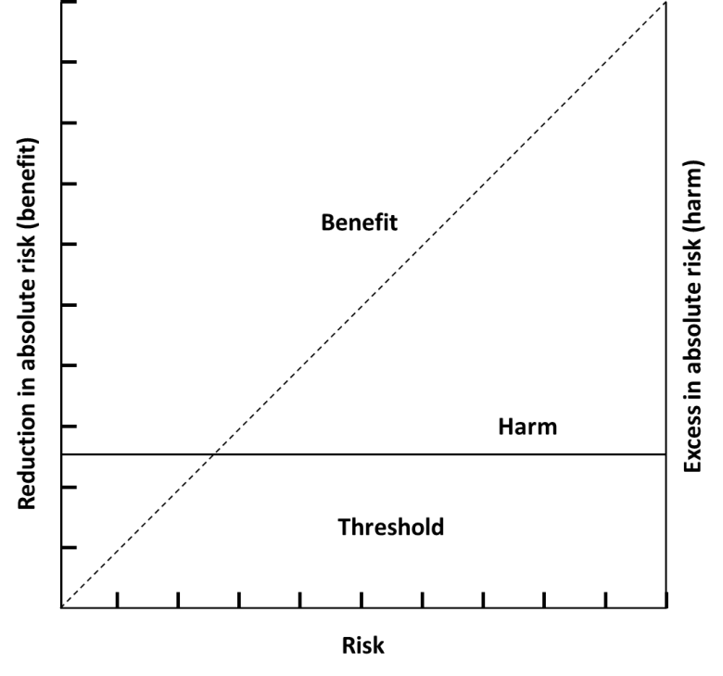
Figure 2 Median and 95% credible intervals net clinical benefit expressed as a function of patient risk (reproduced from Sutton et al.)
