Value functions examples from the Wave 1 Case Study Report Natalizumab
Example of a value function (linear) for an outcome measured as a “proportion of subjects experiencing the event of interest” (flu-like symptoms, PML ...) | 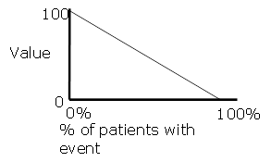
Example of a value function for an outcome measured on a categorical scale  (e.g., route & frequency of administration) | 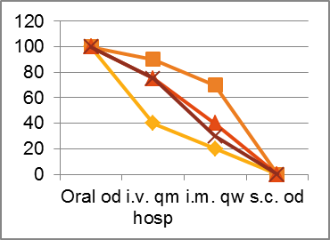
Example of a value function (non-linear) for an outcome measured on a continuous scale(e.g., QT prolongation) | 